The Concept of Abusive Content Free Social Media in Perspective of Bangladesh
Nazia Majadi, Syful Islam, M.H. Kabir

Nowadays the utilization of social media has spread all over the world including Bangladesh. But at present time many abusive contents sharing (i.e., public post, photos or videos in Facebook or online blog) are increasing at an alarming rate. It raises the possibility of engaging in feud between nations, hurts the feeling of religious people, mislead the young generation etc. Usually general people do not know how to stop the visibility of these types of abusive contents. Recently many security systems have been introduced but none of them can ease the process of removing these abusive contents. In this paper we are going to propose a system model, that is arranged in such way that it is capable of receiving complaints with the link of that abusive content, synthesis the whole document into words, check it whether it is abusive or not by comparing the containing words with our system’s abusive word dictionary, verify its importance count the total frequency of complaints for that particular links and take necessary action. The main advantage of our proposed system model is that it is capable of identifying and removing any particular link or id without the stopping the whole site.

Keywords: Database; frequency; IP; Social media; synthesize.
- Introduction
Like many developed and developing countries, the Internet in Bangladesh has witnessed phenomenal growth in 2015-16.Now, internet users of Bangladesh are more than 54.658 million[1]. The number of Internet users in the country is increasing roughly 15-16 percent a year. Internet users continue to spend more time with social media sites than any other type of site. Social media refers to interaction among people in which they create, share, and/or exchange information and ideas in virtual communities and networks. Andreas Kaplan and Michael Haenlein define social media as "a group of Internet-based applications that build on the ideological and technological foundations of Web 2.0, and that allow the creation and exchange of user-generated content. Besides, social media includes web-based and mobile technologies used to turn communication into interactive dialogue .Social-media technologies take on many different forms including magazines, Internet forums, weblogs, social blogs, micro blogging, wikis, social networks, podcasts, photographs or pictures, video, rating and social bookmarking etc[2]. An overwhelming 80 percent internet users of Bangladesh are on social networking website Facebook, authorities monitoring the internet said today[3]. In Bangladesh social networks (facebook. twitter etc) and some blogging sites (somewhereinblog, sachalayatan etc) are most popular. The number of facebook users in Bangladesh on October, 2012 was approximately 3282600. The present number of subscribers cannot be recognized but surely it would be 2-3 times more than in October, 2012. The number of bloggers of somewhereinblog in 2013 was 160000(approx.). The popularity of social media is increasing tremendously day by day in our country and sometimes it plays a vital and more effective role like mainstream media. Through these social networks and blogs people attain entertainment, highlight some important news and views. Moreover, social media site have now become one of the main tools of flourishing democracy as users of it constructively criticize and discuss some vital national, political, religious and sports related issues [4]. It has some positive impact on mitigating crime as Anti-Terrorism Bill 2013 allows Court to accept videos, still photographs and audio clips used in social media websites as evidence for under trial cases[5]. But abusive and ill motivated elements on social media can create warfare between political parties or nations and discord among ethnic and religious communities. For example, “on 29th September 2012 there occurred Ramu violence which includes a series of attacks on Buddhist monasteries, shrines, and houses of Buddhist inhabitants in Ramu Upazila in Cox's Bazar District in Bangladesh by local Muslim mobs on the midnight. The mobs destroyed 22 Buddhist temples and monasteries and 50 houses in reaction to a tagging of an image depicting the desecration of a Quran on the timeline of a fake Facebook account under the Buddhist male name.”For this reason facebook were banned in Bangladesh for a few days. Another example is popular video streaming site YouTube has been blocked in Bangladesh on Sept 17, 2012 after an abusive video on the Prophet Mohammad was uploaded on the site and Google Inc that owns the website did not delete it, creating tensions. The ban was lifted after 260 days! The government has amended the ICT Act 2006 to incorporate a provision of 14 years’ jail term for posting objectionable materials on the internet but despite these problems remain unsolved. Between January and June, the Bangladesh government sought information on 12 Facebook users from the world’s number one social networking website but the Facebook authorities did not provide it. BTRC is not currently well-equipped to conduct the high-level monitoring. The Bangladesh Telecommunication Regulatory Commission has taken up a costly project to make the internet “safe” especially in the wake of probable political confrontations – by filtering data at internet gateways and different social media sites, even news websites, which, many said, would hamper the free flow of information. The project of filtering sensitive data at the internet gateways had started in April, 2013 but it could not be established yet[6]. Through newly adapted project’s technologies BTRC will shut down any website using if it found material that spread social, political and religious hatred. But the BTRC advertisement asked for such a security system that would be able to weed out ‘objectionable’ internet posts from the site without closing it down [7]. It has been heard that several international internet solution providers have expressed their interest in the project. Considering all these factors we are going to propose a new system model that only blocks particular abusive content, not the whole site. The rest of the paper has been organized as follows: Section II provides related research, System Model is given in Section III, and Section IV shows results and discussion, Section V describes recommendation. Finally conclusion is provided in Section VI.
- Related Research
There are very few articles regarding this topic. Authors of this paper have found some articles from online news portal. The Bangladesh CHRONICLE published an article titled “Rights activists fear potential abuse of anti-terrorism law” where they discussed about the challenges of privacy and security in Bangladesh. Dhaka Tribune have published an article titled “BTRC project to filter social media, news sites for ‘safe’ internet”, here the activities of the BTRC(Bangladesh telecommunication Regulatory Commission) about the process of filtering social media contents. Another online portal Prio News said about the legal steps about the abusive contents in the post titled “Effective cyber law needed to control abuse of social media”. PROGRESS BANGLADESH reported on their online portal about the supervision of BTRC on social media in Bangladesh in post titled “Social media coming under watch”.
- Proposed System Model
Our system model is based on detecting fake account, forcing the user to use the real identity & reporting the offensive content in the social media. Our System will have a Database. Database will be managed by the system authority as well as Database Manager. So the whole system comprises of two users: 1) Who Report the Complain 2) Database Management Authority. We mainly work with some most popular social media of Bangladesh. They are- Facebook, Twitter and Online Blogs etc.
- Filtering User Account
Fake accounts are one of the main reason of abusive contents in social media. So in order to control abusive contents, every user in social media must be forced to use proper identity. Our proposed system will force the users in social media to use real identifications. There will be a verification technique in our system to check whether the user account holder of a social media use the proper identity or not. If the user account contains proper identity, the user will be proceeded to post on his/her website wall. If not, the user account will be pended to post on the wall and detected as a malicious user. Then the system will automatically notify them to user proper identity to prevent from being suspended. Again if a new user wants to be added and age less than 18, the user must be recommended be an existing user with proper identity.
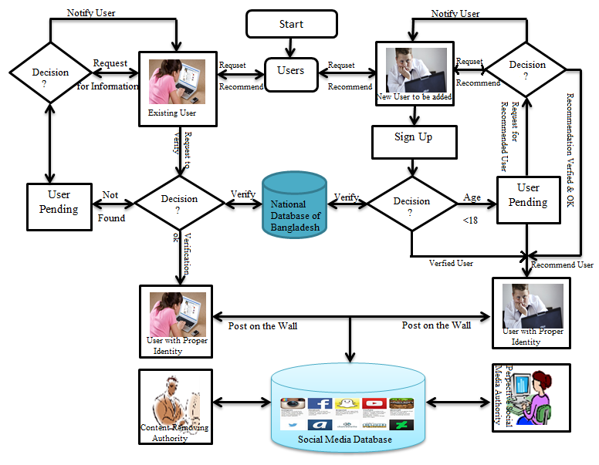
Fig 1: Flow diagram of the proposed system for controlling abusive content
- Architecture of the proposed system
There will be a database in our system model which includes a dictionary of abusive and insulting words. It has a another record book for some Keywords(such as Prophet, Islam, Hinduism, Christians, Buddhist and other religions name, Several Religious Leaders, God and Goddess name, Prime Minister, Honorable and Respected citizens of Bangladesh) . If the obnoxious words containing in the dictionary lie down right and left of those keywords that can be considered as an abusive post by the system and that must be chosen from the reported element of the social media subscriber.
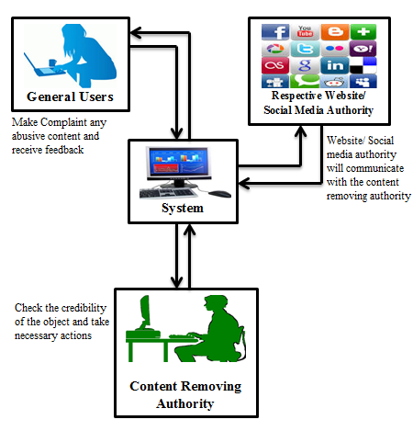
Fig 2: The context diagram of the system
- How to report the abusive content
After seeing abusive post the subscriber of the social media will copy the link of that abusive content. Then He/she will enter into our proposed system and paste that link in the mentioned box. Then he has to write a description why he thought that the content is offensive. Then he has to click the report button. Finally the reported complains will be saved in the system Database. Here one thing should be mentioned that only Bangladeshi IP holder can report their complaints in our system model and one subscriber can report a particular link for only once.
- Synthesize and Comparison
Any report recorded at database will be synthesized into words. Then our system will try to recognize the word is matched with our keyword or not. If it gets any keyword saved in our system’s record book then it will started matching the other words rather than the keyword with the abusive words of system model’s dictionary. If it also found then system will identify the content as abusive one and put it’s to the complained table along with the IP of the subscriber who reports against it.
- How to count the frequency and weight of the report
In our system model the reported content’s link and the reporter’s id will be accumulated in a table. When a particular link is being received it will be flagged as 1 otherwise it will be 0. After receiving another complaint it will match with flag 1 and o. If it is 0, it will be saved in one row below of the previous link and will be flagged as 1. Similar process will be proceeding. We will be able to count how many time a specific link in being complained by its adjacent IPs’ frequencies as one IP is capable of reporting only once for that link. When any link is being complained for many times (say 100) it will be topped in the table and will be highlighted. Then Database Management Authority will check it, consider its weight as well as importance will take necessary measures by blocking the content or make it known to government.
- Performance Analysis
In the existing system there are many hassles. For example: a documentary was shared named “Innocence of Muslim” which is identified as an insulting content to the Muslims as well as for the Prophet (SM). To stop sharing and visibility of this item from YouTube Bangladesh Government stopped YouTube rather than hinder that content only. Our system model can overcome this type of problem. Again the Ramu violence 2012 in Bangladesh was held due to tagging photos in Facebook. For this reason people o Bangladesh were deprived of using Facebook for few days. But our system model is capable enough to block that particular content, it block the respective id and pages, without damaging the overall functioning of the site.
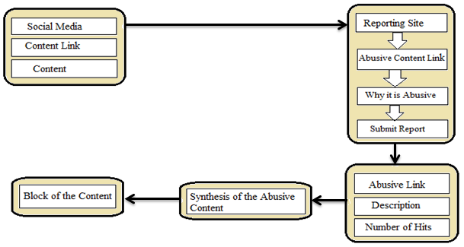
Fig 3: Steps of the whole procedure
- Recommendation
For our proposed system, it may require to make agreement with the social media. The respective authority for this system should be neutral in terms of political and region. Authority should have the power of realizing the sensitivity and importance of the reported content. The freedom of speech must be ensured and the authority should have good consideration power. They should be much efficient and the response against any complaint should be quick enough. Necessary steps should be taken before any further occurrence.
- Comparison between proposed and existing System
Name  Properties | Exsisting System | Proposed System
Local Control on Social Media | Partial control by closing social media temporarily | Full Control on social media
Fake Account Detection? | Partial Control | Full Control
User Anonymity | No Control | Full Control
Abusive Content Control? | Partially but not very responsive | Full Control but agreements required with social media

5. Conclusion
In this paper we have proposed a new system model which helps to wipe out all type of dirty and abusive contents. It is sensate to national, political religion issues. Our system model involves synthesis comparison, counting frequencies, considering weight and importance for recognizing and taking necessary measures. Although we have proposed the model for Bangladesh content but it can be implemented to any other country.
References
[1] Internet subscriber in Bangladesh October ,2015, BTRC (Bangladesh Telecommunication Regulatory Commission), viewd 09 December 2015, http://www.btrc.gov.bd/content/internet-subscribers-bangladesh-october-2015.
[2] Social media, Wikipedia, viewed 29 january 2015, http://en.wikipedia.org/wiki/Social_media

[3] 80pc Bangladesh internet users on Facebook, The Daily Star, Viewed 20 May 2015, http://www.thedailystar.net/country/80pc-bangladesh -internet-users-facebook-83080

[4] Effective cyber law needed to control abuse of social media, PrioNews, viewed 29 january 2015, http://news.priyo.com/gadgets/2012/04/09/effective cyber-law-needed-con-49480.html

[5] Rights activists fear potential abuse of antiterrorism law, THE BANGLADESHTM CHRONICLE, viewd 29 january, 2015, http://www.bangladeshchronicle.net/index.php/2013/06/rights-activists-fear-potential-abuse-of-anti-terrorism-law.
[6] BTRC project to filter social media, news sites for ‘safe’,DhakaTribune, viewed 29 january 2015 , http://www.dhakatribune.com/bangladesh/2013/nov/10/btrc-project-filter-social-media-news-sites %E2%80%98safe%E2%80%99-internet
[7] Social media coming under watch, PROGRESS BANGLADESH, viewed 29 january 2015, http://progressbangladesh.com/social-media-coming-under-watch/

